Political Juggernauts: A Quantitative Analysis Of Candidates In The 2019 Lok Sabha Elections

Lok
Analysis
The
2019
Sabha
Elections.

1
INTRODUCTION
1.1 Overview
The Lok Sabha comprises of a total of 545 seats. Out of these, elections will be conducted by the Election Commission to fill 543 seats. The remaining two seats are filled by nomination of representatives of the Anglo-Indian Community if the President feels that this community has not been represented adequately.
General elections were held in India in seven phases from 11 April to 19 May 2019 to elect the members of the 17th Lok Sabha. Votes were counted and the result was declared on 23 May. The election resulted in a landslide victory for the BJP which won 303 seats and formed the government.
2
Problem Definition & Design Thinking
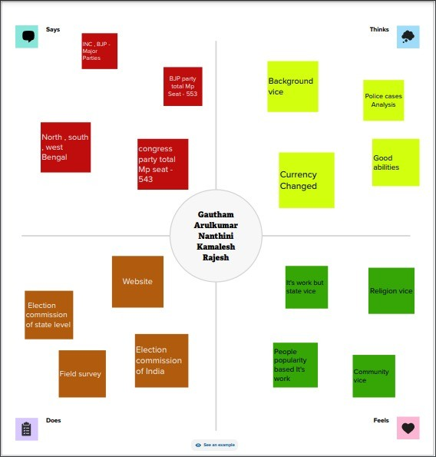
  - Empathy Map
  - Ideation & Brainstorming Map

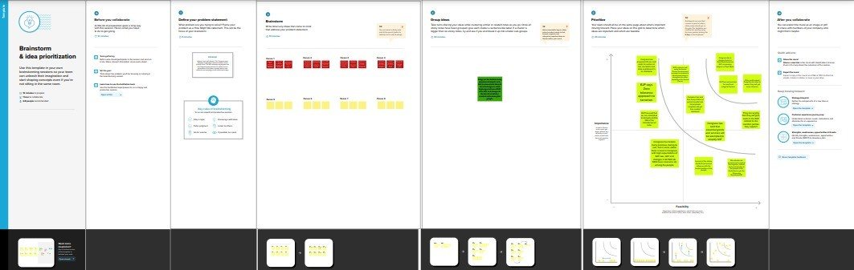

3 RESULT
4 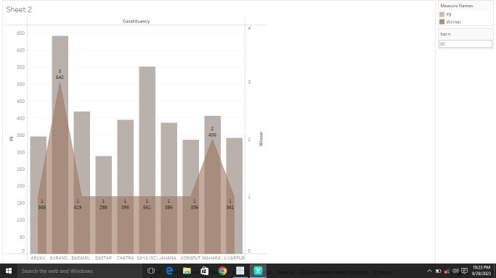

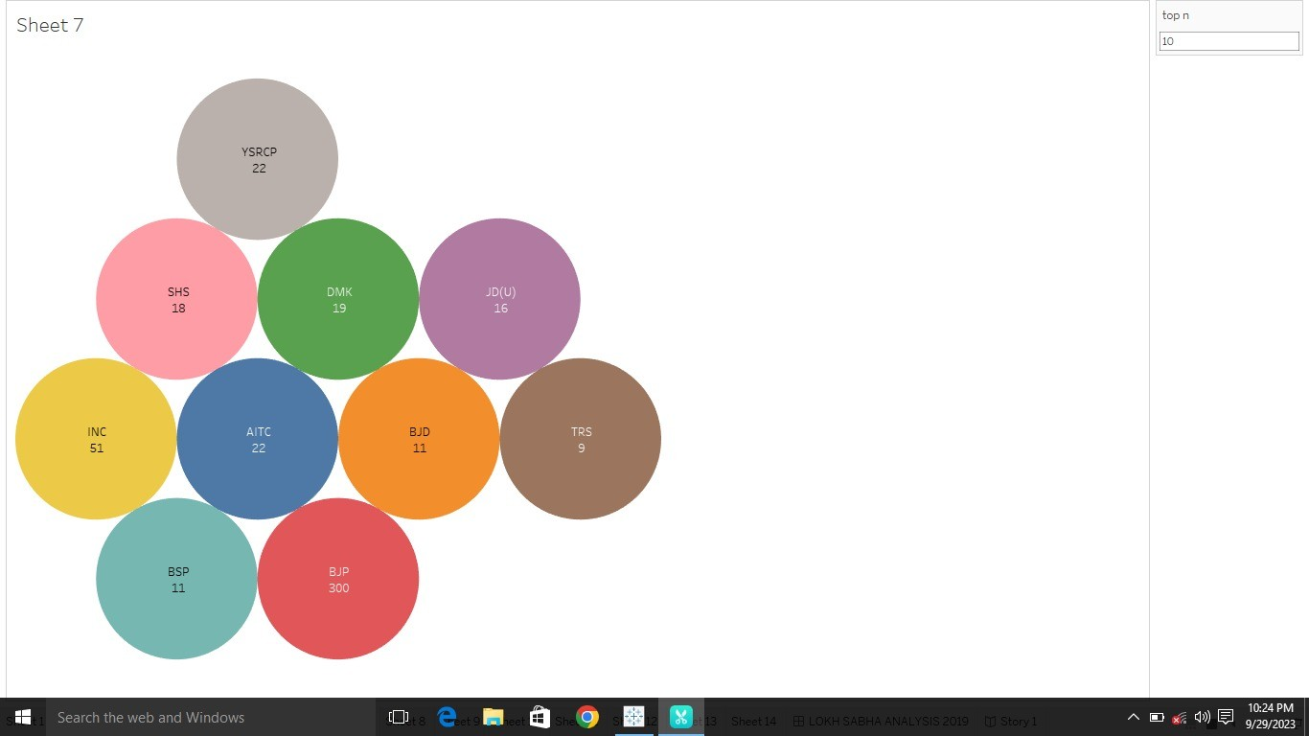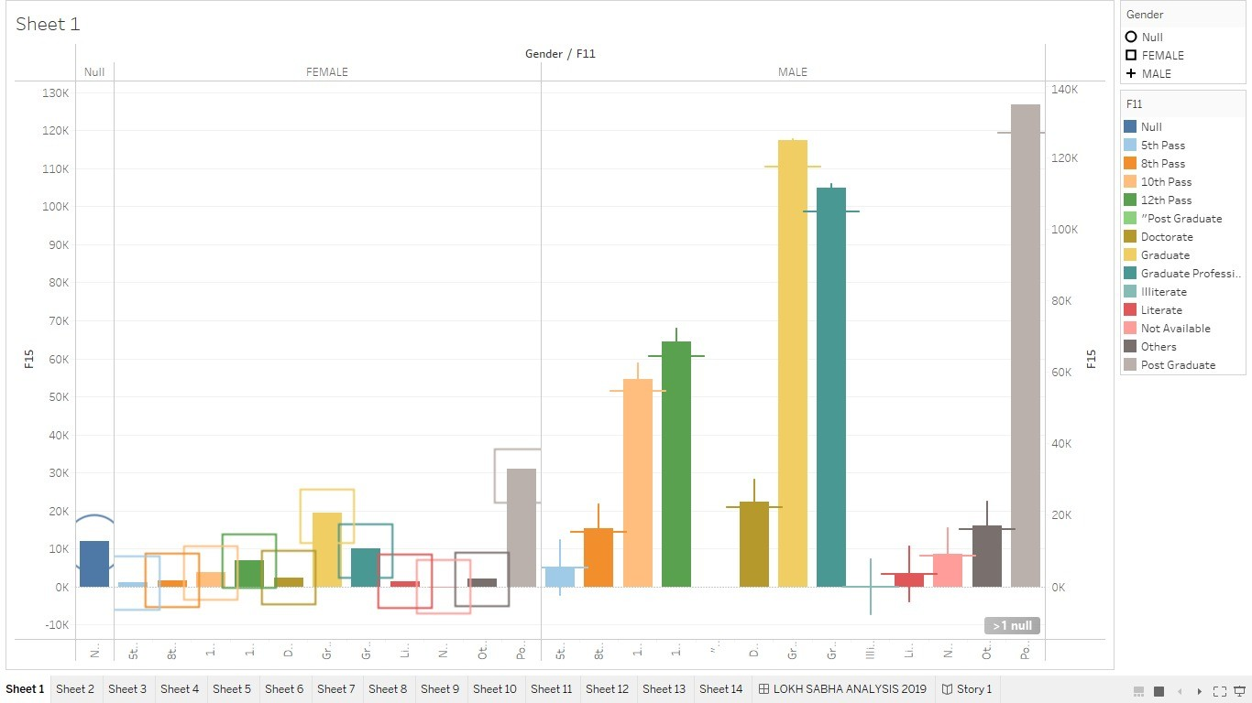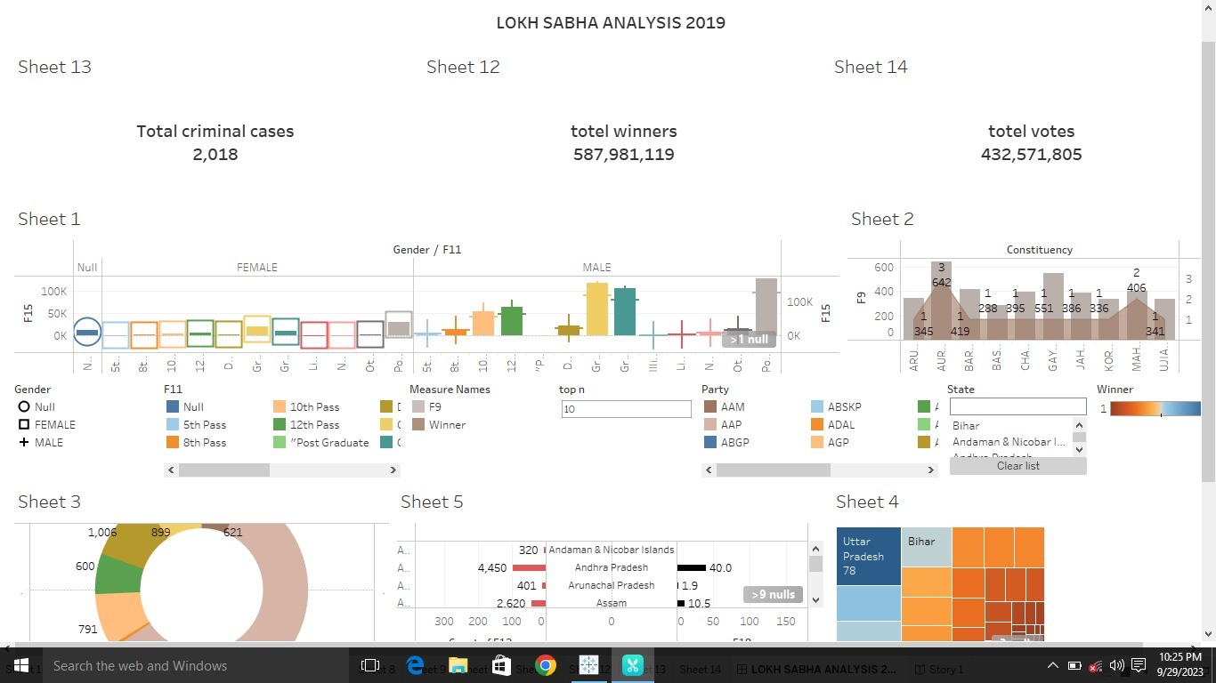

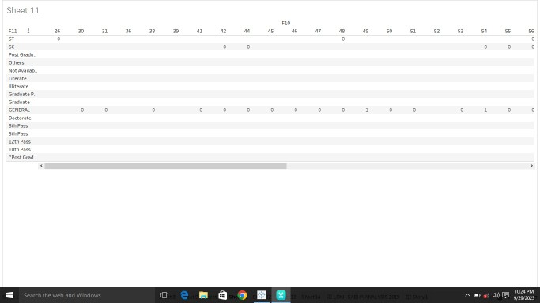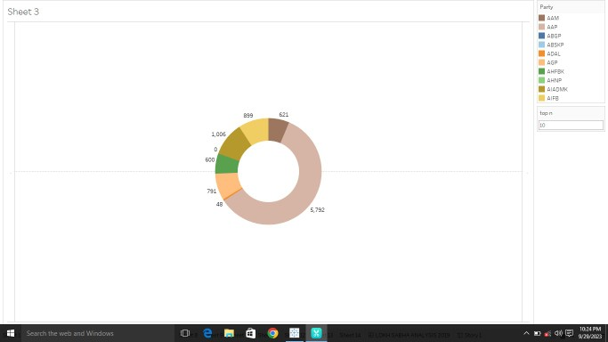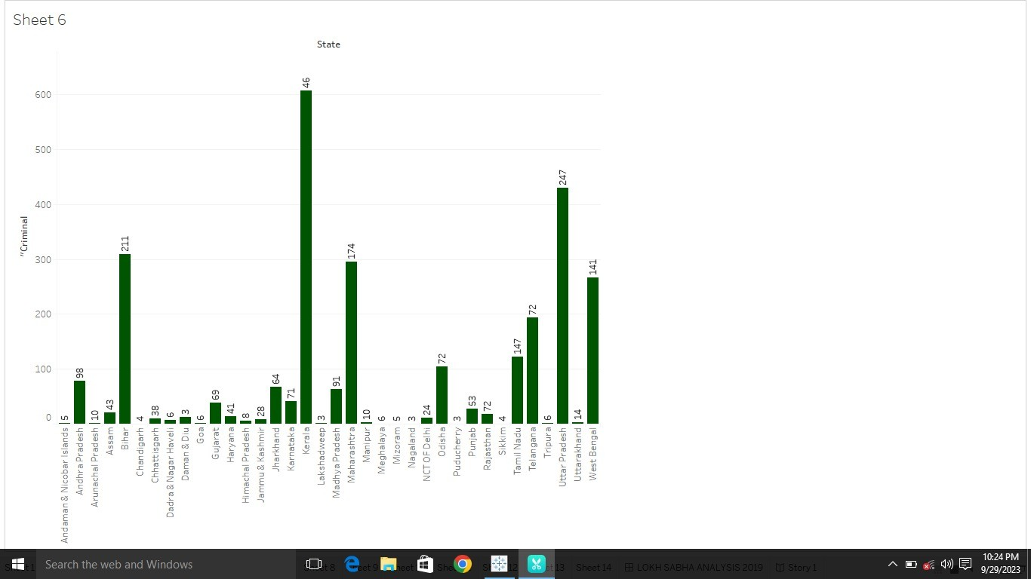

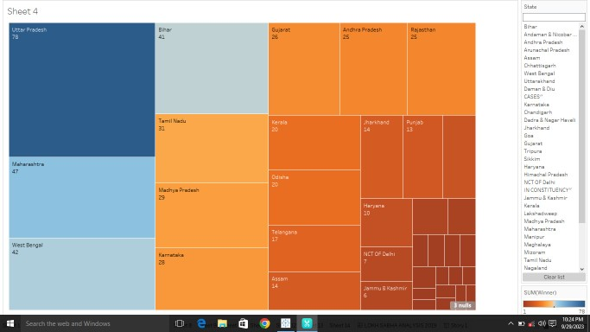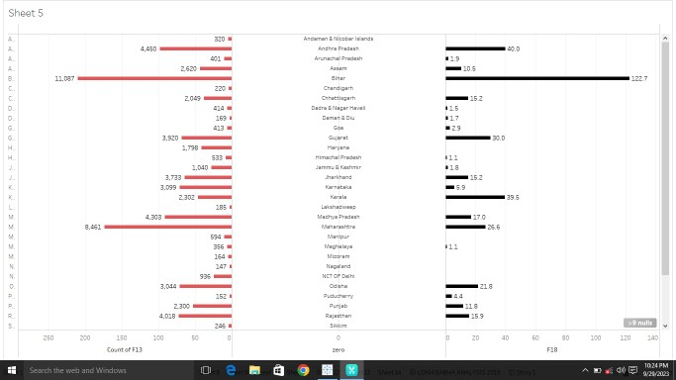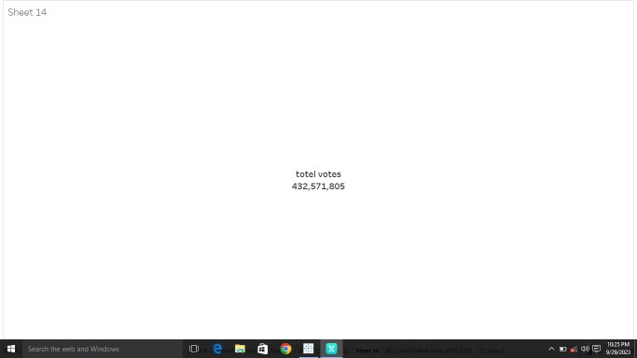

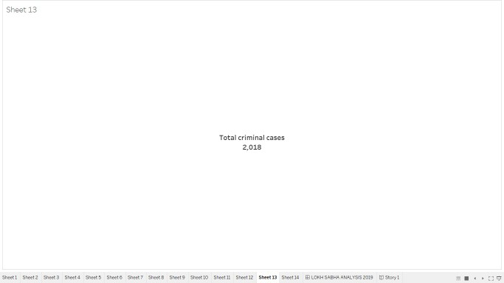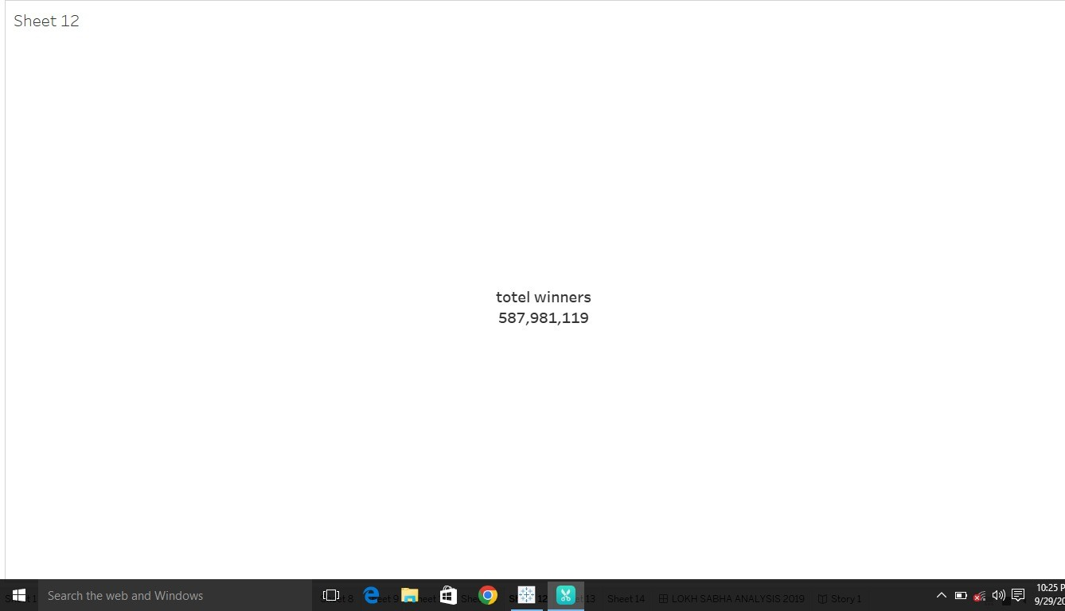

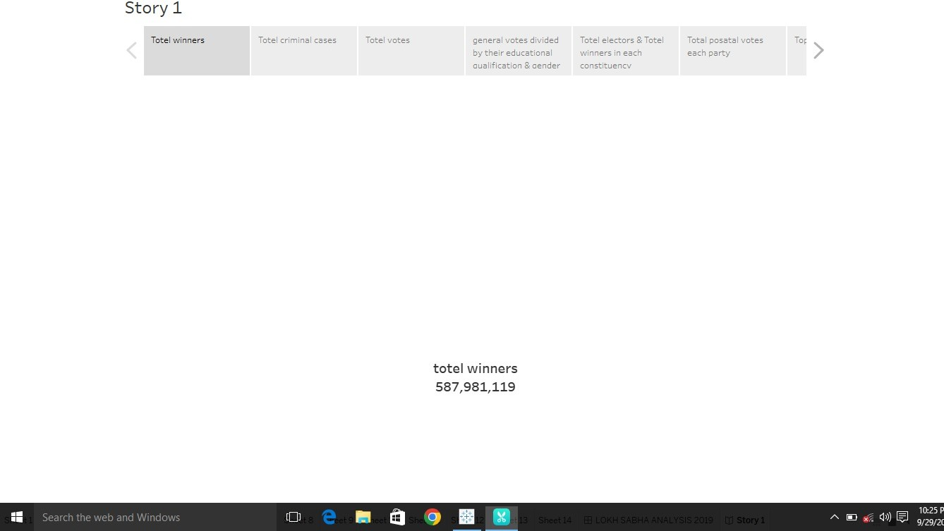
ADVANTAGES & DISADVANTAGES

2019 Lok Sabha election schedule could mean advantage BJP or Congress
ADVANTAGES
- Choice of states going in for multi-phase polling, the number of phases allotted for them and the dates picked have raised questions over ‘suiting’ the BJP.
- BJP believes that Modi is popular in central states and western states and he is becoming popular in states like West Bengal, Odisha and Assam, hence, they want to use him more in these states.
- The second category of states voting in one phase are those where BJP is confident and where it feels the fight is not tough, like Gujarat, Delhi, Haryana, Himachal Pradesh and Uttarakhand.
- Congress has promised to introduce the Nyuntam Aay Yojana (NYAY) under which Rs. 72,000/year will be transferred to the poorest 20 per cent house-holds in India. It will be transferred to the woman in the household .
- Congress says it will present a separate “Kisan Budget” every year. Also the party has promised to bring a permanent National Commission on Agricultural Development and Planning.
- Congress promises to enact the Right to Healthcare Act and guarantee every citizen free diagnostics, out-patient care, free medicines and hospitalisation, through a network of

public hospitals and enlisted private hospitals. The party said it will double expenditure on healthcare to 3 per cent of GDP by 2023-24.

Disadvantages
In states like Tamil Nadu, Kerala and Andhra Pradesh, the BJP knows it can't do much as the Prime Minister is not a vote

grabber.
- APPLICATIONS
If you fulfill your promises in a way that suits the people, you can win the elections.
- CONCLUSION
To win this 2019 Lok Sabha elections, the parties contesting the elections are likely to win if things are done properly as they know the essentials of the people and make promises accordingly and people trust them.
- FUTURE SCOPE
The winning parties should further develop India and keep the economy improving.

8
APPENDIX
https://public.tableau.com/app/profile/gautham.ganesh

